Integrate AdminLTE In Laravel Complete Guide
This is a complete guide to integrate AdminLTE in Laravel. A big help for web developers like me that is not a (pro) front-end developer. This is for you if you want a responsive web app template and you don't want to start from scratch. Thanks to AdminLTE, a popular open source web app template that will help you create admin dashboards and control panels interface.

Steps To Integrate AdminLTE In Laravel
This is a two-step guide with sub-steps that will walk you through to install Laravel using composer and integrate AdminLTE in Laravel.
The following steps uses the Composer dependency management to easily integrate AdminLTE in Laravel.

Step 1: Install Laravel Using Composer
Before we integrate AdminLTE in Laravel, we first need to install Laravel to our server. Remember that Laravel framework has few system requirements. If you’re not using Laravel Homestead then you need to make sure that the following has already installed on your server.
- PHP >= 7.1.3. Open a terminal and check your PHP version by typing php -v command.
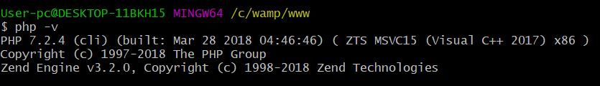
- PHP extensions required are OpenSSL, PDO, Mbstring, Tokenizer, XML, Ctype and JSON. Type php -m command to list all PHP extensions.
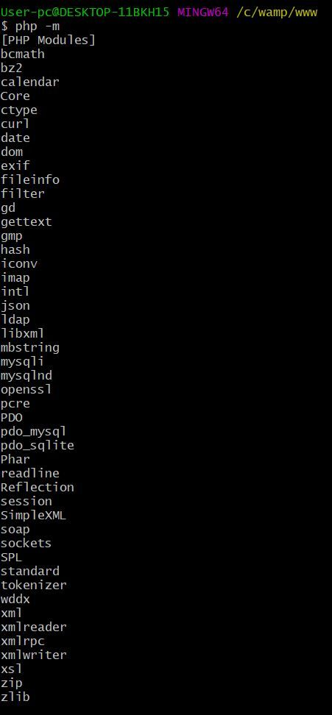
a. From your terminal, navigate to directory where you want to install Laravel.
b. Create your Laravel project using the composer create-project --prefer-dist laravel/laravel command. Composer will install all Laravel's necessary files.
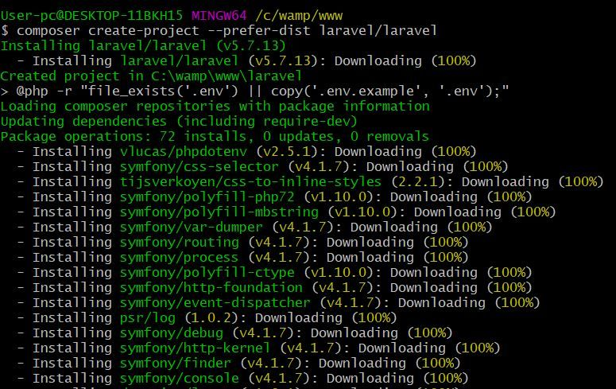
Installation should end with a message Application key set successfully.
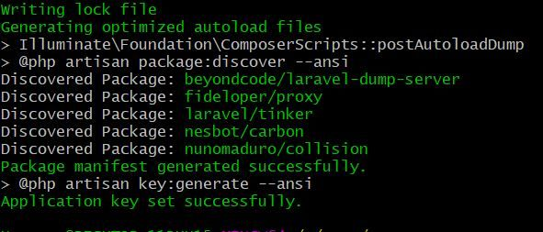
Open a browser and navigate to your project URL.

If the page displays Index of Laravel instead of Laravel's welcome page then perform the following.
If you have PHP installed on your server to serve your project then you can start your Laravel project by executing php artisan serve; Else just move index.php and .htaccess file from your public folder to project main folder.
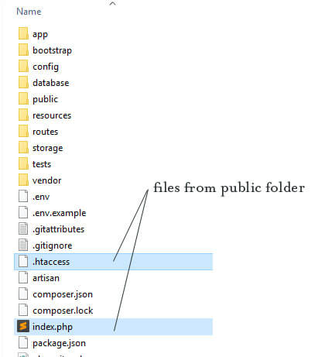
Open index.php and replace require __DIR__.'/../vendor/autoload.php'; with require __DIR__.'/vendor/autoload.php'; and $app = require_once __DIR__.'/../bootstrap/app.php'; with $app = require_once __DIR__.'/bootstrap/app.php';
Save and close the file. Go to your browser and reload your page. Now, you should see the Laravel's welcome page.


Step 2: Integrate AdminLTE In Laravel Using Composer
a. From your terminal, type the command composer require jeroennoten/laravel-adminlte to easily download AdminLTE necessary files.
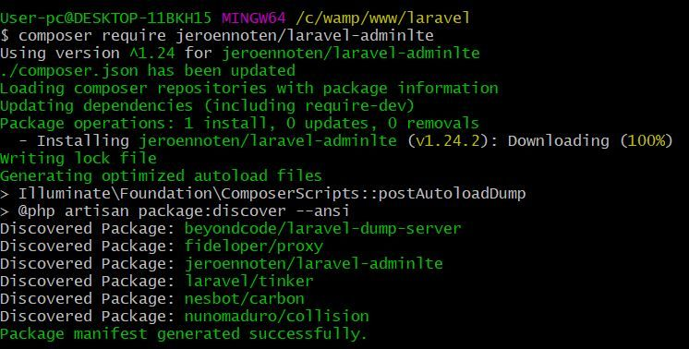
b. Open config/app.php and add this line to Service Providers.
JeroenNotenLaravelAdminLteServiceProvider::class,
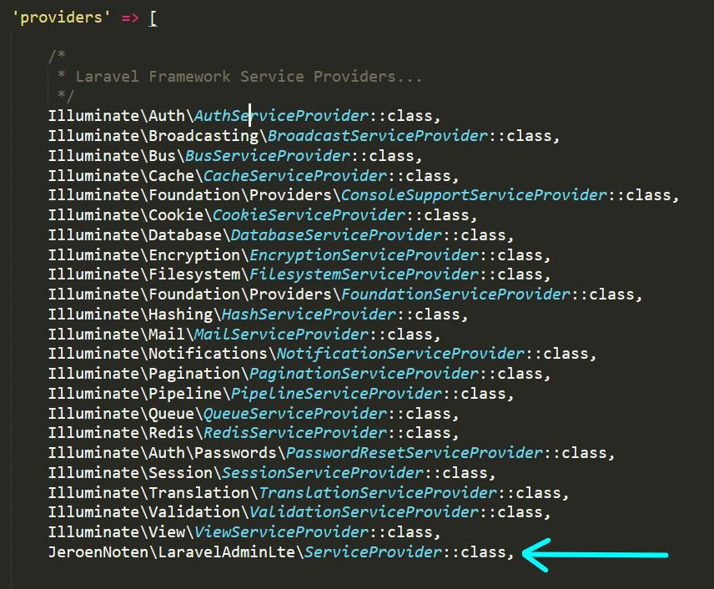
c. Run php artisan vendor:publish --provider="JeroenNotenLaravelAdminLteServiceProvider" --tag=assets command to publish your public assets.
d. Run composer update jeroennoten/laravel-adminlte command to update AdminLTE package.
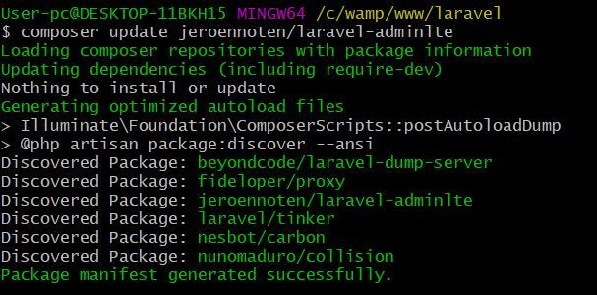
e. Run php artisan vendor:publish --provider="JeroenNotenLaravelAdminLteServiceProvider" --tag=assets --force command to overwrite existing files.
Good Job! You have integrated AdminLTE in Laravel successfully. To appreciate AdminLTE's admin panel beautiful design you may install Laravel's authentication package.

Step 3: Install Laravel's Authentication Package
This step is optional.
a. Run php artisan make:adminlte command to easily download Laravel's authentication package. It is same as make:auth but uses the AdminLTE template.
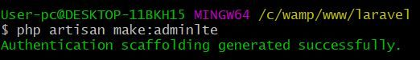
b. Run php artisan vendor:publish --provider="JeroenNotenLaravelAdminLteServiceProvider" --tag=config to publish the configuration file.
You can now edit config/adminlte.php to configure your logo, skin, layout, sidebar, menu and many more.
Go to your browser and reload your page. Now, you should see the Laravel's login page.

Common Issues When Trying To Integrate AdminLTE In Laravel
AdminLTE CSS Path Not Working
Google Dev Tools throws an error Failed to load resource: the server responded with a status of 404 error for some css resources.
Fix the issue by appending public/ to all assets URL. Here's the list of files to update.
- views/auth/passwords/master.blade.php
- views/auth/passwords/login.blade.php
- views/auth/login.blade.php
- views/auth/register.blade.php
- views/auth/verify.blade.php
PHP Artisan Migrate Error
After running php artisan migrate command it throws an error Syntax error or access violation: 1071 Specified key was too long; max key length is 1000 bytes.
To fix the issue you have to edit app/Providers/AppServiceProvider.php file. Inside boot function set a default string length by adding this line Schema::defaultStringLength(191);. Now boot function should look like this.
public function boot()
{
Schema::defaultStringLength(191);
}
We hope this topic on Integrate AdminLTE In Laravel helped you create your responsive web app without starting from scratch.
You may also read Laravel send email using PHPMailer to add email functionality to your Laravel app.
https://scriptwriterph.com/laravel/integrate-adminlte-in-laravel/

Integrate AdminLTE with Laravel 5
Aigars Silkalns General
AdminLTE is a great dashboard template but it is built with pure HTML and CSS. In this tutorial, I'd like to go through installing AdminLTE with Laravel 5 like pros. We will make sure the we have the ability to update AdminLTE to the latest version at any given time by using Bower to manage it.
Looking for a good place to start with Laravel 5? Laracasts provides a great set of video tutorials for programming with Laravel. In this tutorial, I will assume you went through the free Laravel 5 Fundamentals series or at least the first two videos. This tutorial requires basic knowledge of Homestead and the command line (DOS or Terminal).

Tools We Will Use
- Laravel 5
- AdminLTE 2.0.5
- Homestead
- Bower
- Composer

Install a Fresh Copy of Laravel
I will use Laravel's installer to create a new project. Feel free to do it any other way if you feel more comfortable with it.
So let's get the laravel installer. In the terminal type this command
composer global require "laravel/installer=~1.1"
You may need to wait a few minutes until composer completes the installation.
Then get a new copy of Laravel
laravel new myapp
With this command we created a new copy of Laravel and named it myapp. If this command didn't work, make sure you have the Laravel installer setup correctly on your machine.
By now, you should be able to see the welcome page of Laravel when you visit the site.
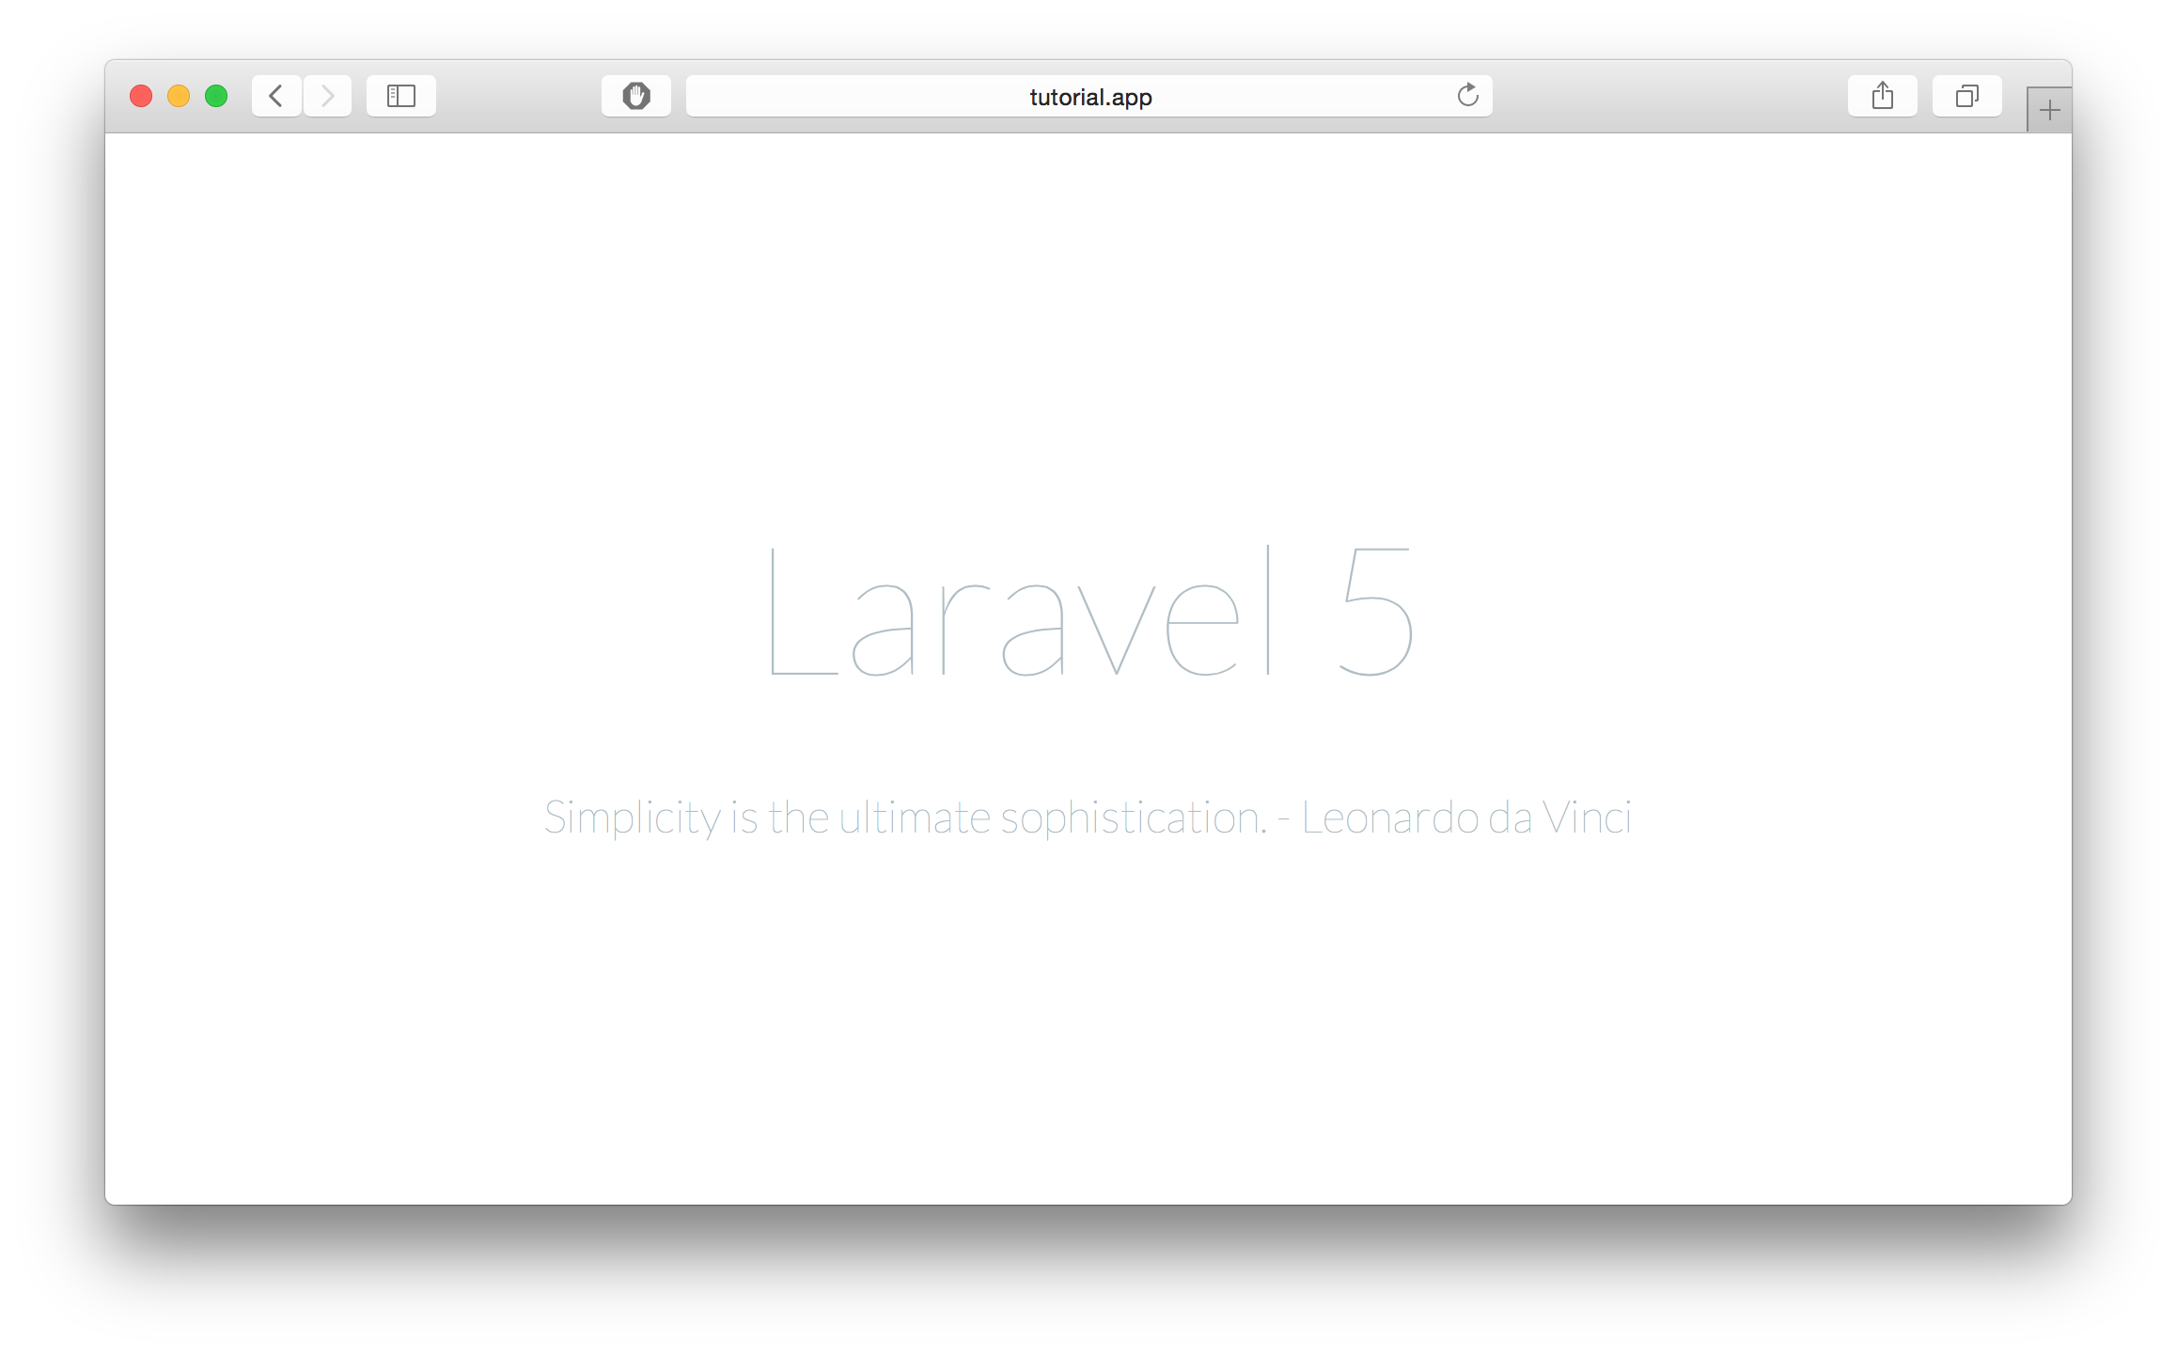

Install AdminLTE via Bower
Navigate to the public directory within your laravel folder.
cd myapp/public
Within the directory, install AdminLTE via Bower
bower install admin-lte
Once it's done, you should have a folder called bower_componets and inside it you will find admin-lte.

Convert AdminLTE starter.html to Blade
Laravel provides a great templating system out of the box called Blade. To take advantage of Blade, we need to convert the regular HTML of the starter page to Blade. First, create a new view in resources/views and call it admin_template.blade.php. Then, create a route to the new view.
The route I am using is setup as follows
Route::get('admin', function () {
return view('admin_template');
});
Now, copy the content of bower_components/admin-lte/starter.html to the new view and modify the asset links to point to the admin-lte directory. Here is my preliminary set up
<!DOCTYPE html>
<!--
This is a starter template page. Use this page to start your new project from
scratch. This page gets rid of all links and provides the needed markup only.
-->
<html>
<head>
<meta charset="UTF-8">
<title>AdminLTE 2 | Dashboard</title>
<meta content='width=device-width, initial-scale=1, maximum-scale=1, user-scalable=no' name='viewport'>
<!-- Bootstrap 3.3.2 -->
<link href="{{ asset("/bower_components/admin-lte/bootstrap/css/bootstrap.min.css") }}" rel="stylesheet" type="text/css" />
<!-- Font Awesome Icons -->
<link href="https://maxcdn.bootstrapcdn.com/font-awesome/4.3.0/css/font-awesome.min.css" rel="stylesheet" type="text/css" />
<!-- Ionicons -->
<link href="http://code.ionicframework.com/ionicons/2.0.0/css/ionicons.min.css" rel="stylesheet" type="text/css" />
<!-- Theme style -->
<link href="{{ asset("/bower_components/admin-lte/dist/css/AdminLTE.min.css")}}" rel="stylesheet" type="text/css" />
<!-- AdminLTE Skins. We have chosen the skin-blue for this starter
page. However, you can choose any other skin. Make sure you
apply the skin class to the body tag so the changes take effect.
-->
<link href="{{ asset("/bower_components/admin-lte/dist/css/skins/skin-blue.min.css")}}" rel="stylesheet" type="text/css" />

<!-- HTML5 Shim and Respond.js IE8 support of HTML5 elements and media queries -->
<!-- WARNING: Respond.js doesn't work if you view the page via file:// -->
<!--[if lt IE 9]>
<script src="https://oss.maxcdn.com/libs/html5shiv/3.7.0/html5shiv.js"></script>
<script src="https://oss.maxcdn.com/libs/respond.js/1.3.0/respond.min.js"></script>
<![endif]-->
</head>
<body class="skin-blue">
<div class="wrapper">

<!-- Main Header -->
<header class="main-header">

<!-- Logo -->
<a href="index2.html" class="logo"><b>Admin</b>LTE</a>

<!-- Header Navbar -->
<nav class="navbar navbar-static-top" role="navigation">
<!-- Sidebar toggle button-->
<a href="#" class="sidebar-toggle" data-toggle="offcanvas" role="button">
<span class="sr-only">Toggle navigation</span>
</a>
<!-- Navbar Right Menu -->
<div class="navbar-custom-menu">
<ul class="nav navbar-nav">
<!-- Messages: style can be found in dropdown.less-->
<li class="dropdown messages-menu">
<!-- Menu toggle button -->
<a href="#" class="dropdown-toggle" data-toggle="dropdown">
<i class="fa fa-envelope-o"></i>
<span class="label label-success">4</span>
</a>
<ul class="dropdown-menu">
<li class="header">You have 4 messages</li>
<li>
<!-- inner menu: contains the messages -->
<ul class="menu">
<li><!-- start message -->
<a href="#">
<div class="pull-left">
<!-- User Image -->
<img src="{{ asset("/bower_components/admin-lte/dist/img/user2-160x160.jpg") }}" class="img-circle" alt="User Image"/>
</div>
<!-- Message title and timestamp -->
<h4>
Support Team
<small><i class="fa fa-clock-o"></i> 5 mins</small>
</h4>
<!-- The message -->
<p>Why not buy a new awesome theme?</p>
</a>
</li><!-- end message -->
</ul><!-- /.menu -->
</li>
<li class="footer"><a href="#">See All Messages</a></li>
</ul>
</li><!-- /.messages-menu -->

<!-- Notifications Menu -->
<li class="dropdown notifications-menu">
<!-- Menu toggle button -->
<a href="#" class="dropdown-toggle" data-toggle="dropdown">
<i class="fa fa-bell-o"></i>
<span class="label label-warning">10</span>
</a>
<ul class="dropdown-menu">
<li class="header">You have 10 notifications</li>
<li>
<!-- Inner Menu: contains the notifications -->
<ul class="menu">
<li><!-- start notification -->
<a href="#">
<i class="fa fa-users text-aqua"></i> 5 new members joined today
</a>
</li><!-- end notification -->
</ul>
</li>
<li class="footer"><a href="#">View all</a></li>
</ul>
</li>
<!-- Tasks Menu -->
<li class="dropdown tasks-menu">
<!-- Menu Toggle Button -->
<a href="#" class="dropdown-toggle" data-toggle="dropdown">
<i class="fa fa-flag-o"></i>
<span class="label label-danger">9</span>
</a>
<ul class="dropdown-menu">
<li class="header">You have 9 tasks</li>
<li>
<!-- Inner menu: contains the tasks -->
<ul class="menu">
<li><!-- Task item -->
<a href="#">
<!-- Task title and progress text -->
<h3>
Design some buttons
<small class="pull-right">20%</small>
</h3>
<!-- The progress bar -->
<div class="progress xs">
<!-- Change the css width attribute to simulate progress -->
<div class="progress-bar progress-bar-aqua" style="width: 20%" role="progressbar" aria-valuenow="20" aria-valuemin="0" aria-valuemax="100">
<span class="sr-only">20% Complete</span>
</div>
</div>
</a>
</li><!-- end task item -->
</ul>
</li>
<li class="footer">
<a href="#">View all tasks</a>
</li>
</ul>
</li>
<!-- User Account Menu -->
<li class="dropdown user user-menu">
<!-- Menu Toggle Button -->
<a href="#" class="dropdown-toggle" data-toggle="dropdown">
<!-- The user image in the navbar-->
<img src="{{ asset("/bower_components/admin-lte/dist/img/user2-160x160.jpg") }}" class="user-image" alt="User Image"/>
<!-- hidden-xs hides the username on small devices so only the image appears. -->
<span class="hidden-xs">Alexander Pierce</span>
</a>
<ul class="dropdown-menu">
<!-- The user image in the menu -->
<li class="user-header">
<img src="{{ asset("/bower_components/admin-lte/dist/img/user2-160x160.jpg") }}" class="img-circle" alt="User Image" />
<p>
Alexander Pierce - Web Developer
<small>Member since Nov. 2012</small>
</p>
</li>
<!-- Menu Body -->
<li class="user-body">
<div class="col-xs-4 text-center">
<a href="#">Followers</a>
</div>
<div class="col-xs-4 text-center">
<a href="#">Sales</a>
</div>
<div class="col-xs-4 text-center">
<a href="#">Friends</a>
</div>
</li>
<!-- Menu Footer-->
<li class="user-footer">
<div class="pull-left">
<a href="#" class="btn btn-default btn-flat">Profile</a>
</div>
<div class="pull-right">
<a href="#" class="btn btn-default btn-flat">Sign out</a>
</div>
</li>
</ul>
</li>
</ul>
</div>
</nav>
</header>
<!-- Left side column. contains the logo and sidebar -->
<aside class="main-sidebar">

<!-- sidebar: style can be found in sidebar.less -->
<section class="sidebar">

<!-- Sidebar user panel (optional) -->
<div class="user-panel">
<div class="pull-left image">
<img src="{{ asset("/bower_components/admin-lte/dist/img/user2-160x160.jpg") }}" class="img-circle" alt="User Image" />
</div>
<div class="pull-left info">
<p>Alexander Pierce</p>
<!-- Status -->
<a href="#"><i class="fa fa-circle text-success"></i> Online</a>
</div>
</div>

<!-- search form (Optional) -->
<form action="#" method="get" class="sidebar-form">
<div class="input-group">
<input type="text" name="q" class="form-control" placeholder="Search..."/>
<span class="input-group-btn">
<button type='submit' name='search' id='search-btn' class="btn btn-flat"><i class="fa fa-search"></i></button>
</span>
</div>
</form>
<!-- /.search form -->

<!-- Sidebar Menu -->
<ul class="sidebar-menu">
<li class="header">HEADER</li>
<!-- Optionally, you can add icons to the links -->
<li class="active"><a href="#"><span>Link</span></a></li>
<li><a href="#"><span>Another Link</span></a></li>
<li class="treeview">
<a href="#"><span>Multilevel</span> <i class="fa fa-angle-left pull-right"></i></a>
<ul class="treeview-menu">
<li><a href="#">Link in level 2</a></li>
<li><a href="#">Link in level 2</a></li>
</ul>
</li>
</ul><!-- /.sidebar-menu -->
</section>
<!-- /.sidebar -->
</aside>

<!-- Content Wrapper. Contains page content -->
<div class="content-wrapper">
<!-- Content Header (Page header) -->
<section class="content-header">
<h1>
Page Header
<small>Optional description</small>
</h1>
<ol class="breadcrumb">
<li><a href="#"><i class="fa fa-dashboard"></i> Level</a></li>
<li class="active">Here</li>
</ol>
</section>

<!-- Main content -->
<section class="content">

<!-- Your Page Content Here -->

</section><!-- /.content -->
</div><!-- /.content-wrapper -->

<!-- Main Footer -->
<footer class="main-footer">
<!-- To the right -->
<div class="pull-right hidden-xs">
Anything you want
</div>
<!-- Default to the left -->
<strong>Copyright © 2015 <a href="#">Company</a>.</strong> All rights reserved.
</footer>

</div><!-- ./wrapper -->

<!-- REQUIRED JS SCRIPTS -->

<!-- jQuery 2.1.3 -->
<script src="{{ asset ("/bower_components/admin-lte/plugins/jQuery/jQuery-2.1.3.min.js") }}"></script>
<!-- Bootstrap 3.3.2 JS -->
<script src="{{ asset ("/bower_components/admin-lte/bootstrap/js/bootstrap.min.js") }}" type="text/javascript"></script>
<!-- AdminLTE App -->
<script src="{{ asset ("/bower_components/admin-lte/dist/js/app.min.js") }}" type="text/javascript"></script>

<!-- Optionally, you can add Slimscroll and FastClick plugins.
Both of these plugins are recommended to enhance the
user experience -->
</body>
</html>
If you visit the page again, you should see the starter template working. The result should look like this
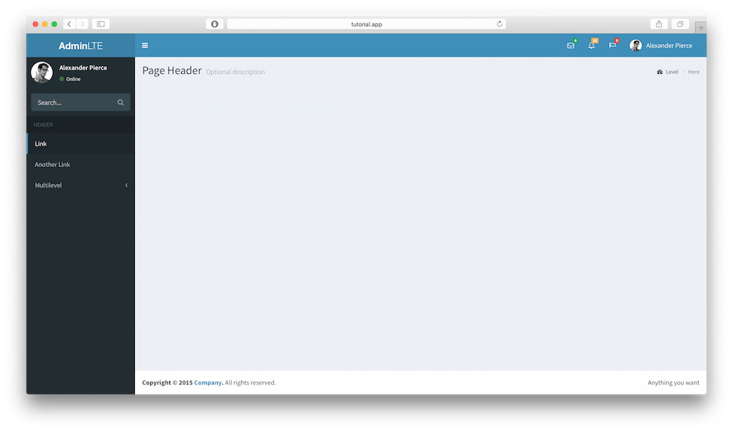
Now that we have all the resources we need to start with AdminLTE, lets add the final touches to our main view. I will split the template into three files, sidebar.blade.php, header.blade.php, and footer.blade.php. So create those files in the views directory, then add the necessary code in each file as follows.
1. header.blade.php
<!-- Main Header -->
<header class="main-header">

<!-- Logo -->
<a href="index2.html" class="logo"><b>Admin</b>LTE</a>

<!-- Header Navbar -->
<nav class="navbar navbar-static-top" role="navigation">
<!-- Sidebar toggle button-->
<a href="#" class="sidebar-toggle" data-toggle="offcanvas" role="button">
<span class="sr-only">Toggle navigation</span>
</a>
<!-- Navbar Right Menu -->
<div class="navbar-custom-menu">
<ul class="nav navbar-nav">
<!-- Messages: style can be found in dropdown.less-->
<li class="dropdown messages-menu">
<!-- Menu toggle button -->
<a href="#" class="dropdown-toggle" data-toggle="dropdown">
<i class="fa fa-envelope-o"></i>
<span class="label label-success">4</span>
</a>
<ul class="dropdown-menu">
<li class="header">You have 4 messages</li>
<li>
<!-- inner menu: contains the messages -->
<ul class="menu">
<li><!-- start message -->
<a href="#">
<div class="pull-left">
<!-- User Image -->
<img src="{{ asset("/bower_components/admin-lte/dist/img/user2-160x160.jpg") }}" class="img-circle" alt="User Image"/>
</div>
<!-- Message title and timestamp -->
<h4>
Support Team
<small><i class="fa fa-clock-o"></i> 5 mins</small>
</h4>
<!-- The message -->
<p>Why not buy a new awesome theme?</p>
</a>
</li><!-- end message -->
</ul><!-- /.menu -->
</li>
<li class="footer"><a href="#">See All Messages</a></li>
</ul>
</li><!-- /.messages-menu -->

<!-- Notifications Menu -->
<li class="dropdown notifications-menu">
<!-- Menu toggle button -->
<a href="#" class="dropdown-toggle" data-toggle="dropdown">
<i class="fa fa-bell-o"></i>
<span class="label label-warning">10</span>
</a>
<ul class="dropdown-menu">
<li class="header">You have 10 notifications</li>
<li>
<!-- Inner Menu: contains the notifications -->
<ul class="menu">
<li><!-- start notification -->
<a href="#">
<i class="fa fa-users text-aqua"></i> 5 new members joined today
</a>
</li><!-- end notification -->
</ul>
</li>
<li class="footer"><a href="#">View all</a></li>
</ul>
</li>
<!-- Tasks Menu -->
<li class="dropdown tasks-menu">
<!-- Menu Toggle Button -->
<a href="#" class="dropdown-toggle" data-toggle="dropdown">
<i class="fa fa-flag-o"></i>
<span class="label label-danger">9</span>
</a>
<ul class="dropdown-menu">
<li class="header">You have 9 tasks</li>
<li>
<!-- Inner menu: contains the tasks -->
<ul class="menu">
<li><!-- Task item -->
<a href="#">
<!-- Task title and progress text -->
<h3>
Design some buttons
<small class="pull-right">20%</small>
</h3>
<!-- The progress bar -->
<div class="progress xs">
<!-- Change the css width attribute to simulate progress -->
<div class="progress-bar progress-bar-aqua" style="width: 20%" role="progressbar" aria-valuenow="20" aria-valuemin="0" aria-valuemax="100">
<span class="sr-only">20% Complete</span>
</div>
</div>
</a>
</li><!-- end task item -->
</ul>
</li>
<li class="footer">
<a href="#">View all tasks</a>
</li>
</ul>
</li>
<!-- User Account Menu -->
<li class="dropdown user user-menu">
<!-- Menu Toggle Button -->
<a href="#" class="dropdown-toggle" data-toggle="dropdown">
<!-- The user image in the navbar-->
<img src="{{ asset("/bower_components/admin-lte/dist/img/user2-160x160.jpg") }}" class="user-image" alt="User Image"/>
<!-- hidden-xs hides the username on small devices so only the image appears. -->
<span class="hidden-xs">Alexander Pierce</span>
</a>
<ul class="dropdown-menu">
<!-- The user image in the menu -->
<li class="user-header">
<img src="{{ asset("/bower_components/admin-lte/dist/img/user2-160x160.jpg") }}" class="img-circle" alt="User Image" />
<p>
Alexander Pierce - Web Developer
<small>Member since Nov. 2012</small>
</p>
</li>
<!-- Menu Body -->
<li class="user-body">
<div class="col-xs-4 text-center">
<a href="#">Followers</a>
</div>
<div class="col-xs-4 text-center">
<a href="#">Sales</a>
</div>
<div class="col-xs-4 text-center">
<a href="#">Friends</a>
</div>
</li>
<!-- Menu Footer-->
<li class="user-footer">
<div class="pull-left">
<a href="#" class="btn btn-default btn-flat">Profile</a>
</div>
<div class="pull-right">
<a href="#" class="btn btn-default btn-flat">Sign out</a>
</div>
</li>
</ul>
</li>
</ul>
</div>
</nav>
</header>
2. sidebar.blade.php
<!-- Left side column. contains the sidebar -->
<aside class="main-sidebar">

<!-- sidebar: style can be found in sidebar.less -->
<section class="sidebar">

<!-- Sidebar user panel (optional) -->
<div class="user-panel">
<div class="pull-left image">
<img src="{{ asset("/bower_components/admin-lte/dist/img/user2-160x160.jpg") }}" class="img-circle" alt="User Image" />
</div>
<div class="pull-left info">
<p>Alexander Pierce</p>
<!-- Status -->
<a href="#"><i class="fa fa-circle text-success"></i> Online</a>
</div>
</div>

<!-- search form (Optional) -->
<form action="#" method="get" class="sidebar-form">
<div class="input-group">
<input type="text" name="q" class="form-control" placeholder="Search..."/>
<span class="input-group-btn">
<button type='submit' name='search' id='search-btn' class="btn btn-flat"><i class="fa fa-search"></i></button>
</span>
</div>
</form>
<!-- /.search form -->

<!-- Sidebar Menu -->
<ul class="sidebar-menu">
<li class="header">HEADER</li>
<!-- Optionally, you can add icons to the links -->
<li class="active"><a href="#"><span>Link</span></a></li>
<li><a href="#"><span>Another Link</span></a></li>
<li class="treeview">
<a href="#"><span>Multilevel</span> <i class="fa fa-angle-left pull-right"></i></a>
<ul class="treeview-menu">
<li><a href="#">Link in level 2</a></li>
<li><a href="#">Link in level 2</a></li>
</ul>
</li>
</ul><!-- /.sidebar-menu -->
</section>
<!-- /.sidebar -->
</aside>
3. footer.blade.php

<footer class="main-footer">
<!-- To the right -->
<div class="pull-right hidden-xs">
Anything you want
</div>
<!-- Default to the left -->
<strong>Copyright © 2015 <a href="#">Company</a>.</strong> All rights reserved.
</footer>

Final Touches
We have the pieces of the template split for easy customization. Now we need to customize our original admin_template.blade.php to load those files and allow for dynamic content loading. Here is my final code for admin_template.blade.php
<!DOCTYPE html>
<!--
This is a starter template page. Use this page to start your new project from
scratch. This page gets rid of all links and provides the needed markup only.
-->
<html>
<head>
<meta charset="UTF-8">
<title>{{ $page_title or "AdminLTE Dashboard" }}</title>
<meta content='width=device-width, initial-scale=1, maximum-scale=1, user-scalable=no' name='viewport'>
<!-- Bootstrap 3.3.2 -->
<link href="{{ asset("/bower_components/admin-lte/bootstrap/css/bootstrap.min.css") }}" rel="stylesheet" type="text/css" />
<!-- Font Awesome Icons -->
<link href="https://maxcdn.bootstrapcdn.com/font-awesome/4.3.0/css/font-awesome.min.css" rel="stylesheet" type="text/css" />
<!-- Ionicons -->
<link href="http://code.ionicframework.com/ionicons/2.0.0/css/ionicons.min.css" rel="stylesheet" type="text/css" />
<!-- Theme style -->
<link href="{{ asset("/bower_components/admin-lte/dist/css/AdminLTE.min.css")}}" rel="stylesheet" type="text/css" />
<!-- AdminLTE Skins. We have chosen the skin-blue for this starter
page. However, you can choose any other skin. Make sure you
apply the skin class to the body tag so the changes take effect.
-->
<link href="{{ asset("/bower_components/admin-lte/dist/css/skins/skin-blue.min.css")}}" rel="stylesheet" type="text/css" />

<!-- HTML5 Shim and Respond.js IE8 support of HTML5 elements and media queries -->
<!-- WARNING: Respond.js doesn't work if you view the page via file:// -->
<!--[if lt IE 9]>
<script src="https://oss.maxcdn.com/libs/html5shiv/3.7.0/html5shiv.js"></script>
<script src="https://oss.maxcdn.com/libs/respond.js/1.3.0/respond.min.js"></script>
<![endif]-->
</head>
<body class="skin-blue">
<div class="wrapper">

<!-- Header -->
@include('header')

<!-- Sidebar -->
@include('sidebar')

<!-- Content Wrapper. Contains page content -->
<div class="content-wrapper">
<!-- Content Header (Page header) -->
<section class="content-header">
<h1>
{{ $page_title or "Page Title" }}
<small>{{ $page_description or null }}</small>
</h1>
<!-- You can dynamically generate breadcrumbs here -->
<ol class="breadcrumb">
<li><a href="#"><i class="fa fa-dashboard"></i> Level</a></li>
<li class="active">Here</li>
</ol>
</section>

<!-- Main content -->
<section class="content">
<!-- Your Page Content Here -->
@yield('content')
</section><!-- /.content -->
</div><!-- /.content-wrapper -->

<!-- Footer -->
@include('footer')

</div><!-- ./wrapper -->

<!-- REQUIRED JS SCRIPTS -->

<!-- jQuery 2.1.3 -->
<script src="{{ asset ("/bower_components/admin-lte/plugins/jQuery/jQuery-2.1.3.min.js") }}"></script>
<!-- Bootstrap 3.3.2 JS -->
<script src="{{ asset ("/bower_components/admin-lte/bootstrap/js/bootstrap.min.js") }}" type="text/javascript"></script>
<!-- AdminLTE App -->
<script src="{{ asset ("/bower_components/admin-lte/dist/js/app.min.js") }}" type="text/javascript"></script>

<!-- Optionally, you can add Slimscroll and FastClick plugins.
Both of these plugins are recommended to enhance the
user experience -->
</body>
</html>
In the code above, we added a section called content that will contain our pages, loaded the header, footer, and sidebar, and added $page_title variable to give our pages titles. The template is now ready to be used with Laravel 5.

Test Page
To demonstrate where to go from there, I will create a simple page that shows a box with progress bars containing dynamically generated tasks.
1. Create test.blade.php. Within the views folder, create a new file and add the following code to it.
@extends('admin_template')

@section('content')
<div class='row'>
<div class='col-md-6'>
<!-- Box -->
<div class="box box-primary">
<div class="box-header with-border">
<h3 class="box-title">Randomly Generated Tasks</h3>
<div class="box-tools pull-right">
<button class="btn btn-box-tool" data-widget="collapse" data-toggle="tooltip" title="Collapse"><i class="fa fa-minus"></i></button>
<button class="btn btn-box-tool" data-widget="remove" data-toggle="tooltip" title="Remove"><i class="fa fa-times"></i></button>
</div>
</div>
<div class="box-body">
@foreach($tasks as $task)
<h5>
{{ $task['name'] }}
<small class="label label-{{$task['color']}} pull-right">{{$task['progress']}}%</small>
</h5>
<div class="progress progress-xxs">
<div class="progress-bar progress-bar-{{$task['color']}}" style="width: {{$task['progress']}}%"></div>
</div>
@endforeach

</div><!-- /.box-body -->
<div class="box-footer">
<form action='#'>
<input type='text' placeholder='New task' class='form-control input-sm' />
</form>
</div><!-- /.box-footer-->
</div><!-- /.box -->
</div><!-- /.col -->
<div class='col-md-6'>
<!-- Box -->
<div class="box box-primary">
<div class="box-header with-border">
<h3 class="box-title">Second Box</h3>
<div class="box-tools pull-right">
<button class="btn btn-box-tool" data-widget="collapse" data-toggle="tooltip" title="Collapse"><i class="fa fa-minus"></i></button>
<button class="btn btn-box-tool" data-widget="remove" data-toggle="tooltip" title="Remove"><i class="fa fa-times"></i></button>
</div>
</div>
<div class="box-body">
A separate section to add any kind of widget. Feel free
to explore all of AdminLTE widgets by visiting the demo page
on <a href="https://almsaeedstudio.com">Almsaeed Studio</a>.
</div><!-- /.box-body -->
</div><!-- /.box -->
</div><!-- /.col -->

</div><!-- /.row -->
@endsection
2. Create Controller TestControler.php. Create a new controller by using the following command
php artisan make:controller TestController --plain
The code for the new controller
<?php namespace App\Http\Controllers;

use App\Http\Requests;
use App\Http\Controllers\Controller;

use Illuminate\Http\Request;

class TestController extends Controller {

public function index() {
$data['tasks'] = [
[
'name' => 'Design New Dashboard',
'progress' => '87',
'color' => 'danger'
],
[
'name' => 'Create Home Page',
'progress' => '76',
'color' => 'warning'
],
[
'name' => 'Some Other Task',
'progress' => '32',
'color' => 'success'
],
[
'name' => 'Start Building Website',
'progress' => '56',
'color' => 'info'
],
[
'name' => 'Develop an Awesome Algorithm',
'progress' => '10',
'color' => 'success'
]
];
return view('test')->with($data);
}

}
3. Create a Route. Now that we have a controller, we need a new route to point to it. Within the routes.php file, copy the following route:
Route::get('test', 'TestController@index');
If everything has been done correctly, you should be able to see result similar to this when visiting the test page.
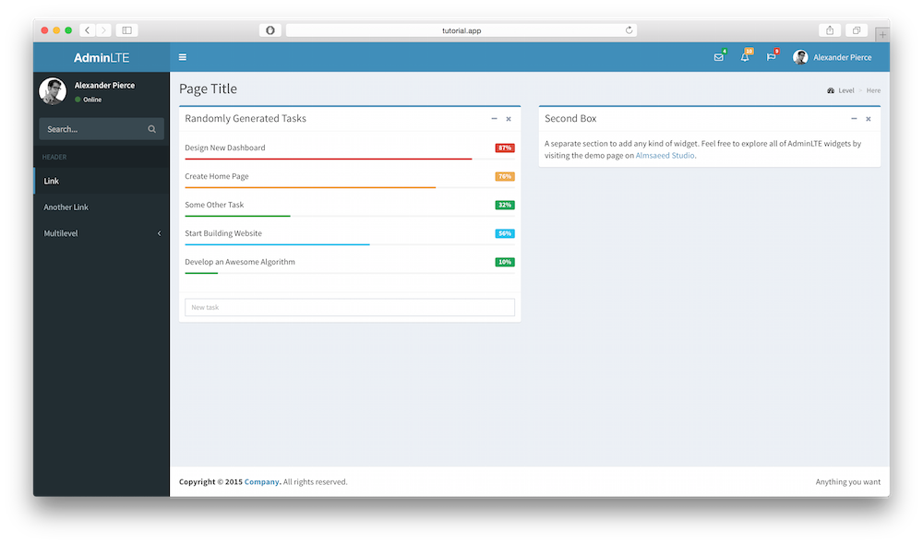

Download & Conclusion
Download: AdminLTE-and-Laravel.zip
I hope you enjoyed this tutorial. Do not hesitate to comment or ask questions below.
https://adminlte.io/blog/integrate-adminlte-with-laravel

